[ EMBEDDED C PROGRAMMING ASSIGNMENT ]

NAME :- SHUBHAM PRAJAPATI

COURSE :- BTECH ( ELECTRICAL ENGINEERING )

SUBJECT :- PROGRAMMING FUNDAMENTALS FOR ELECTRONICS ENGINEERS

ADMISSION NUMBER :- 25SECE1050013

- Write a Program to set(enable ) the 5th bit of a it register .
#code
#include <stdio.h>
int main() {
int reg;
printf("Enter register value: ");
scanf("%d", &reg);
reg = reg | (1 << 4);
printf("Value after setting 5th bit: %d\n", reg);

return 0;
}

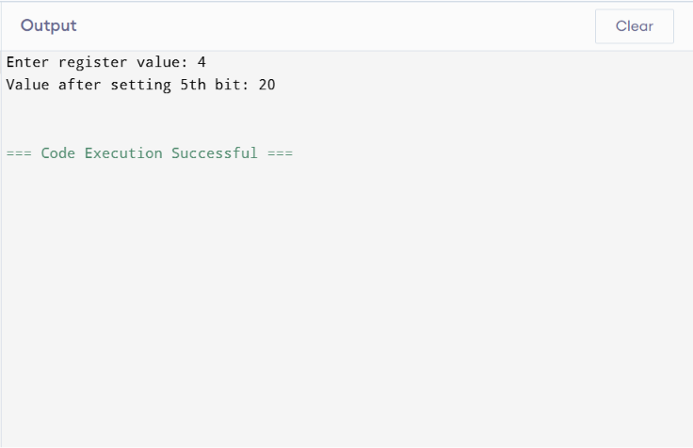

- Write a program to clear the 2nd bit of a 16- bit register .
#code
#include <stdio.h>

int main() {
unsigned short reg;
printf("Enter register value: ");
scanf("%hu", &reg)
reg = reg & ~(1 << 1);

printf("Value after clearing 2nd bit: %hu\n", reg);

return 0;
}

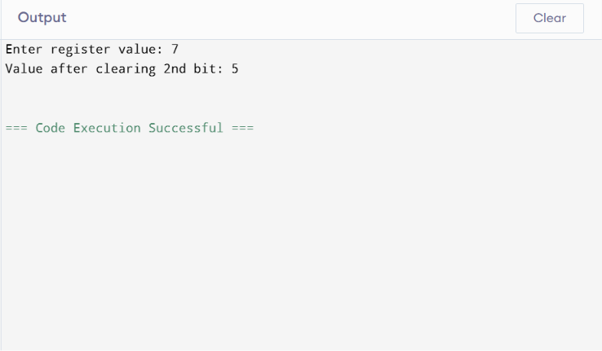

3.Write a program to toggle the 7th bit of an 8 bit register.
#code
#include <stdio.h>
int main() {
unsigned char reg;
printf("Enter register value: ");
scanf("%hhu", &reg);
reg = reg ^ (1 << 6);
printf("Value after toggling 7th bit: %hhu\n", reg);
return 0;
}
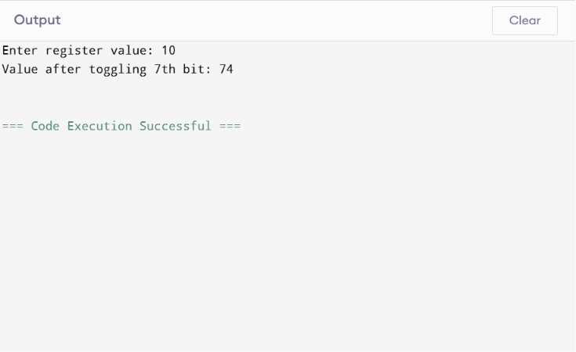

4.Write a program to check whether a given bit position is set or not .(4th bit )
#code
#include <stdio.h>
int main() {
int num;
printf("Enter a number: ");
scanf("%d", &num);
if (num & (1 << 3)) {
printf("4th bit is SET\n");
} else {
printf("4th bit is NOT SET\n");
}

return 0;
}
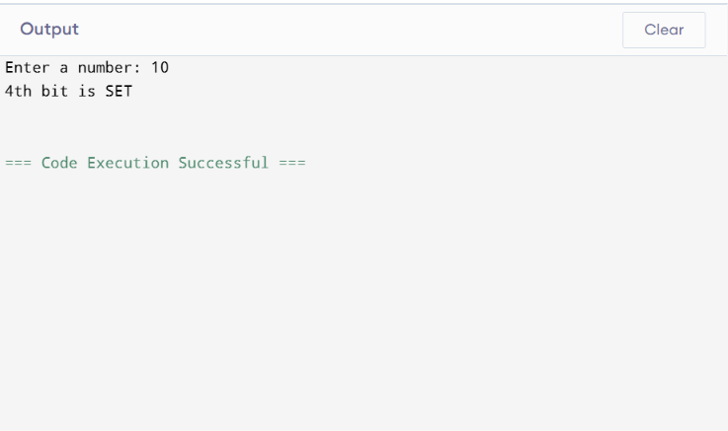

5.Write a program to count the number of set bits(1s) in a number.
#code
#include <stdio.h>
int main() {
int num, count = 0;
printf("Enter a number: ");
scanf("%d", &num);

while (num > 0) {
if (num & 1) {
count++;
}
num = num >> 1;
}
printf("Number of set bits = %d\n", count);

return 0;
}
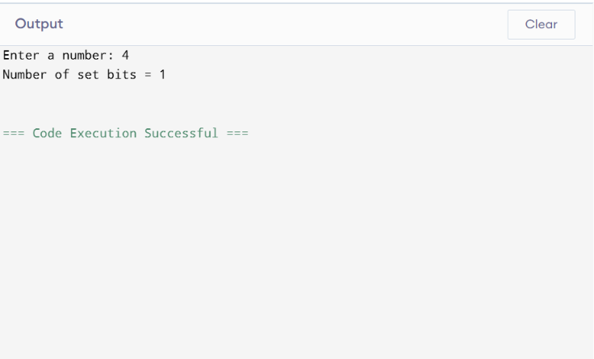
6. Write a program to perform left shift and right shift operations on a number and display result .
#code
#include <stdio.h>
int main() {
int num, leftShift, rightShift;
printf("Enter a number: ");
scanf("%d", &num);
leftShift = num << 1;
rightShift = num >> 1;
printf("After Left Shift by 1: %d\n", leftShift);
printf("After Right Shift by 1: %d\n", rightShift);

return 0;
}
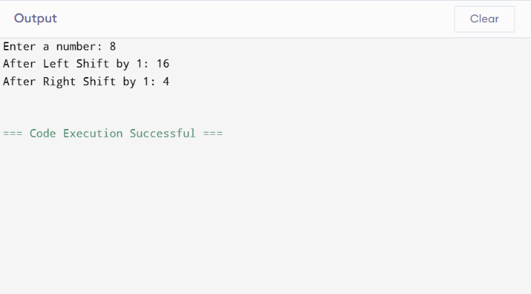
7. Write a program to swap two numbers using bitwise XOR.
#code
#include <stdio.h>
int main() {
int a, b;
printf("Enter first number: ");
scanf("%d", &a);
printf("Enter second number: ");
scanf("%d", &b);
printf("\nBefore swapping:\n");
printf("a = %d\nb = %d\n", a, b);
a = a ^ b;
b = a ^ b;
a = a ^ b;
printf("\nAfter swapping:\n");
printf("a = %d\nb = %d\n", a, b);
return 0;
}
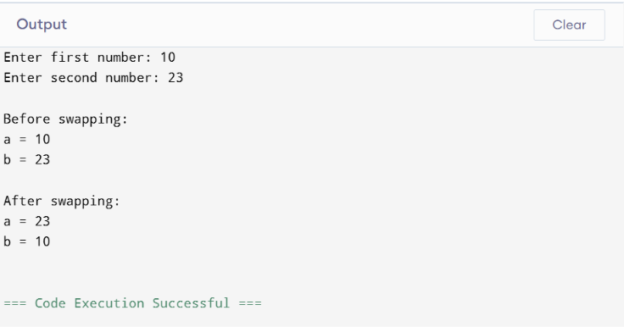

8. Write a program to clear all bits except a specific bit position.
#code
#include <stdio.h>
int main() {
int num, pos, result;
printf("Enter a number: ");
scanf("%d", &num);
printf("Enter bit position to keep (0-based index): ");
scanf("%d", &pos);
result = num & (1 << pos);
printf("Result after clearing all bits except position %d = %d\n", pos, result);
return 0;
}
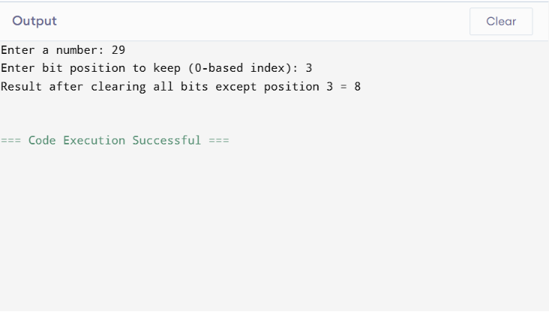

9. Write a program to blink a led connected to pin number 2 of a microcontroller. Use software delay.
#code
#include <REGX51.H>
sbit LED = P2^0;
void delay() {
unsigned int i, j;
for(i = 0; i < 1000; i++) {
for(j = 0; j < 100; j++);
}
}
void main() {
while(1) {
LED = 0;
delay();
LED = 1;
delay();
}
}

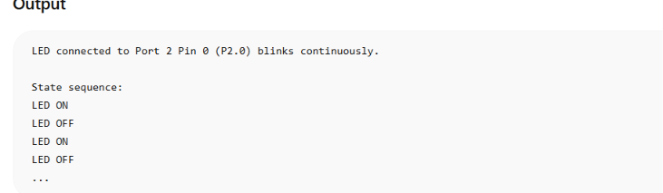
10. Write an embedded C program to check the temperature. If it is more than 35 degree Centigrade, send high signal to fan so that it can turn on.
#code
#include <REGX51.H>
sbit FAN = P2^0;
void main()
{
unsigned char temperature;
while(1)
{
temperature = P1;
if(temperature > 35)
{
FAN = 1;
}
else
{
FAN = 0;
}
}
}

#Output
